Animals of the Short Grass Prairie

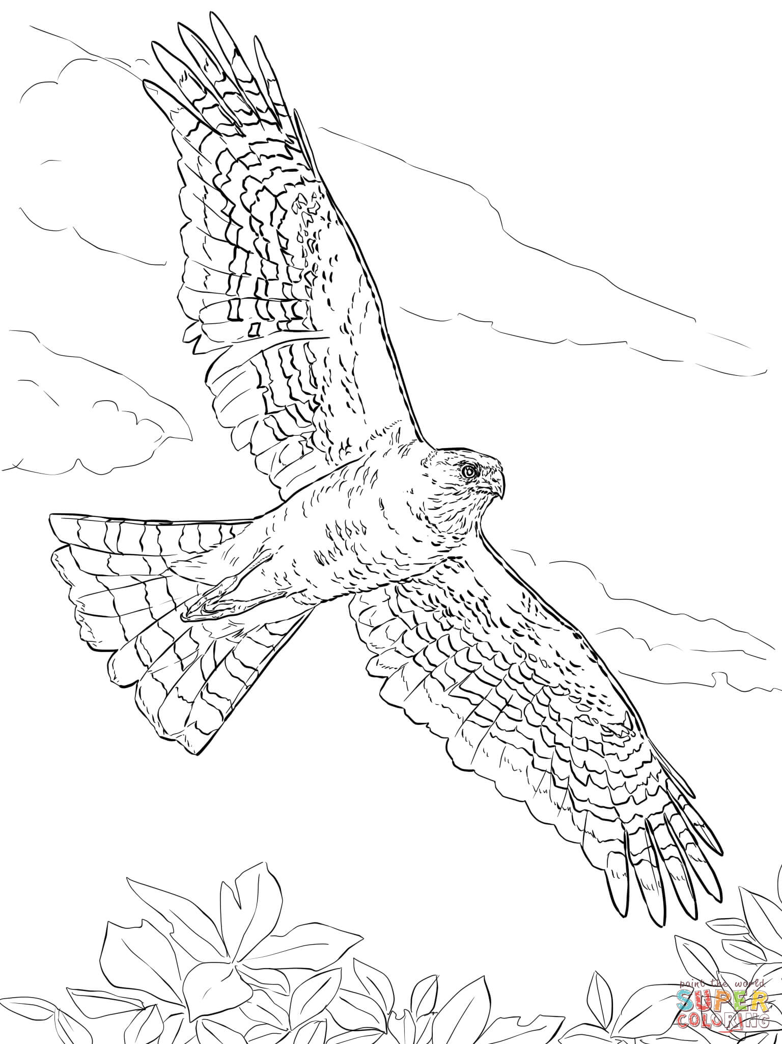
www.azcoloring.com-Red-tailed Hawk www.azcoloring.com

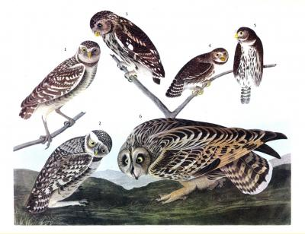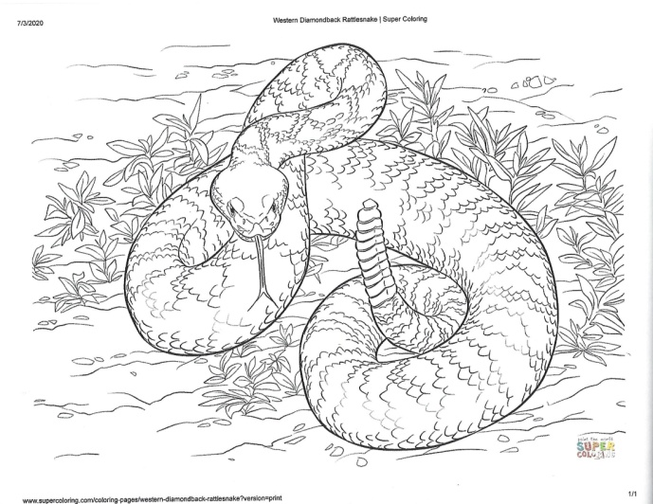
Print by John James Audobon www.supercoloring.com
University of Missouri-St. Louis Fine Art Collection

